**FARMER’S BUDDY**

|  |  |
| --- | --- |
| **CONTENT** | **PAGE NO** |
| **Abstract** |  |
| **1.INTRODUCTION** |  |
| 1.1 Motivation |  |
| 1.2 Problem Statement |  |
| 1.3 Objective of the Project |  |
| 1.4 Scope |  |
| 1.5 Project Introduction |  |
| **2.LTERATURE SURVEY** |  |
| 2.1 Related Work |  |
| **3. SYSTEM ANALYSIS** |  |
| 3.1 Existing System |  |
| 3.2 Disadvantages |  |
| 3.3 Proposed System |  |
| 3.4 Advantages |  |
| 3.5 work Flow of Proposed system |  |
| **4. REQUIREMENT ANALYSIS** |  |
| 4.1Function and non-functional requirements |  |
| 4.2 Hardware Requirements |  |
| 4.3 Software Requirements |  |
| 4.4 Architecture |  |
| **5. SYSTEM DESIGN** |  |
| 5.1 Introduction of Input design |  |
| 5.2 UML Diagram(class, use case, sequence, collaborative, deployment, |  |
| 5.3 Data Flow Diagram |  |
| **6. IMPLEMENTATION AND RESULTS** |  |
| 6.1 Modules |  |
| 6.2 Output Screens |  |
| 1. **PYTHON ENVIRONMENT** |  |
| 7.1 Software Installation |  |
| 7.2 About Python Language |  |
| 1. **SYSTEM STUDY AND TESTING** |  |
| 8.1 Feasibility study |  |
| 8.2 Types of test |  |
| **9. CONCLUSION** |  |
| **10. FUTURE ENHANCEMENT** |  |
| **11. REFERENCES** |  |

**ABSTRACT**

This abstract outlines the key aspects of a farmer's soil check and addresses the doubts and concerns commonly associated with a farming project. The soil check is a crucial step in understanding the soil's composition and quality, which directly impacts the success and productivity of agricultural endeavors. By conducting a comprehensive soil analysis, farmers can make informed decisions regarding crop selection, fertilization strategies, and overall land management practices. Additionally, addressing doubts and concerns related to farming projects is essential for ensuring optimal planning and execution, as it helps farmers overcome potential challenges and achieve desired outcomes. This abstract provides a brief overview of the significance of soil testing and addresses common doubts faced by farmers during the implementation of farming projects.

**Keywords**: Farming, Soil checking, questions, answers, Farmer , Panchayath.

1. **INTRODUCTION**

**1.1 Motivation:**

Understanding the soil's composition and nutrient levels is crucial for maximizing crop productivity. Soil testing provides valuable insights into the availability of essential nutrients, pH levels, and soil structure, enabling farmers to make informed decisions about fertilization and soil management practices. By addressing soil deficiencies and imbalances, farmers can optimize nutrient uptake by plants, leading to healthier crops and increased yields. Addressing doubts and concerns associated with farming projects helps mitigate risks. By identifying potential challenges and uncertainties early on, farmers can develop contingency plans and take proactive measures to minimize the impact of adverse conditions such as extreme weather events, pest outbreaks, or market fluctuations. This proactive approach enhances the resilience of farming operations and safeguards against potential losses.

**1.2 Problem Statement:**

The current state of the farmer's soil quality assessment is inadequate, leading to suboptimal farming practices and reduced crop yields. There is a lack of accessible and accurate information about the soil composition, nutrient levels, and overall health, making it difficult for farmers to make informed decisions regarding fertilization, irrigation, and crop selection. This knowledge gap not only hampers the farmers' productivity but also has long-term negative implications for the environment and sustainability of agriculture

**1.3 Objective of the Project:**

The objective of a farmer's Buddy check is to accurately assess the quality and health of the soil in order to optimize farming practices and improve crop yields. By conducting soil tests, farmers can determine the nutrient content, pH levels, organic matter, and other important parameters that directly impact plant growth. The goal is to provide farmers with actionable information and recommendations to make informed decisions regarding fertilization, irrigation, soil amendments, and crop selection. Ultimately, the objective is to enhance agricultural productivity, promote sustainable farming practices, and ensure long-term soil health.

**1.4 Scope:**

The scope of the project "Farmers Buddy" can vary depending on the specific objectives and features of the application. Develop a methodology for proper soil sampling, including determining the sampling locations, depth, and quantity of soil samples needed for accurate analysis. Farmers may question the nutrient status of their soil and how to address nutrient deficiencies effectively.

**1.5 Project Introduction:**

Introduction to the "Farmers Buddy" Project:

Farmers Buddy is an innovative and comprehensive digital solution aimed at empowering farmers by providing them with access to vital information and tools for improving their farming practices. This project harnesses the power of technology to address the challenges faced by farmers, particularly in the realm of soil health and agricultural productivity.

With the mission of enhancing crop yields, promoting sustainable farming methods, and improving overall agricultural outcomes, Farmers Buddy offers a user-friendly platform that serves as a reliable companion for farmers throughout their farming journey. By integrating advanced soil testing, data analysis, and personalized recommendations, Farmers Buddy equips farmers with the knowledge and resources necessary to make informed decisions and optimize their farming practices.

The core features of Farmers Buddy include soil testing and analysis, data management, recommendations and best practices, knowledge sharing, and integration with external services. By conducting soil tests, farmers can assess the quality and health of their soil, understand its nutrient composition, pH levels, and other crucial factors that directly impact crop growth. The platform then provides farmers with tailored recommendations for fertilization strategies, irrigation techniques, and soil amendments based on the specific needs of their soil.

Farmers Buddy goes beyond mere data analysis and recommendations by also offering educational resources, tutorials, and access to agricultural experts. This empowers farmers with the necessary knowledge and skills to interpret soil test results accurately and implement sustainable farming practices that improve soil health and fertility.

The project aims to leverage the convenience and accessibility of technology to reach a wide range of farmers, regardless of their location or scale of operations. Farmers Buddy is designed to be user-friendly, with a mobile and web-based interface that simplifies the process of collecting soil samples, conducting tests, and managing data.

By adopting Farmers Buddy, farmers can overcome the challenges associated with inadequate soil information, make informed decisions to optimize their farming practices, and ultimately increase crop yields while promoting sustainable agricultural practices.

Farmers Buddy is not just a digital tool; it is a comprehensive solution that acts as a trusted companion for farmers, empowering them to make data-driven decisions, improve productivity, and contribute to the long-term sustainability of agriculture.

1. **LITERATURE SURVEY**

**2.1 Related Work:**

**A.T.M Shaikh Ahamed, Navid Tanzeem Mahmod, Rasedur M Rahman, ”Applying Data Mining Techniques to predict annual yield of major crop and recommended planting different crops in different Districts in Bangladesh. ”, 2015.**

This paper proposes an approach of using Hadoop for processing such Big volumes, variety and velocity of weather data. It includes application of Artificial Neural Network which is a convenient approach. ANN is implemented on Map-Reduce framework for short term rainfall prediction. Additionally, method will detect soil and Regional analysis which can also detect crop depending on user’s location. Crop data along with feasibility check of soil condition is provided so as to help farmer/users in decisive situation.

**Viraj Patodkar1, Sujit Simant2, ShubhamSharma3, Chirag Shah4, Prof. Sachin Godse5, “EAgro Android Application (Integrated Farming Management Systems)”2015[1]**

Agriculture is the backbone of Indian economy as farmers are suffering from huge economic losses. Farmers areconfused to take correct decision regarding selection of fertilizer, pesticides, etc., time to do particular farming actions and the price fortheir products that they produce and sell. To overcome all problems, we proposed an android-based app, which addresses the issues offarmers, benefits them with additional guidance regarding soil type, fertilizers, pesticide, irrigation requirements etc.

**Prof.P.B.Gaikwad, Pallavi Malode, Pooja Pawar, Sangita Darade, “E-Farming an Interface for Indian Farming” 2015[4]**

Today the mobile phone is used and in that most are the smart phones. Android is the mobile operating system used in smart phone, most of android applications are freely available for user. The use of smart phone is increase in every sector. So in this we use Horticulture concept and Android is used for a Farmer Helping Service system that will provide the detail information of fruits, vegetables to the farmers. And this information will also provide information in audio form also. This system can provide information using android smart phone from anywhere and anytime without using internet and at free of cost. It is very useful to Maharashtra Farmer because they will get information in Marathi Language just by typing number from the mobile keypad.

**O. O. Mazhara, S. I. Shapovalovam ,“Production System for Express Diagnostics of the Agriculture and Natural Resources Objects for Portable Devices”2016[7]**

 Farmer’s buddy is a java based application for farmers to know which season is better for which crop and what soils are used for crops these are clearly known in this application . In this application, the admin will log in, add seasons, season time and what soil suitable for what crop also admin add the all the necessary details. Admin can view the user queries if any registered user sends the query to the admin and admin sends the solution to the users.

**VCS Agriculture, Forestry and Other Land Use (AFOLU) Requirements, version 3.4. (2013).** [**http://www.v-cs.org/program-documents**](http://www.v-cs.org/program-documents)

The basis of this document was the VCS 2007.1, the Guidance for Agriculture, Forestry and Other Land Use Projects and the Tool for AFOLU Methodological Issues, developed by the VCS AFOLU Advisory Group (a group composed of working groups of leading experts in each of the six AFOLU project categories) in 2007 and 2008 through an extensive peer review process

**Aniket Bhave, Rahul Joshi, Ryan Fernandes, “Mahafarm An Andriod based solution for remunerative Agriculture” 2014[2]**

Advancement of ICT can be utilized for providing accurate and timely relevant information and services to the farmers, thereby facilitating an environment for remunerative agriculture. This paper describes a mobile based application for farmers which would exhaustively help them in their farming activities. We propose an android based mobile application – ‘MahaFarm’ .

**3. SYSTEM ANALYSIS**

**3.1 Existing System**

While soil checking provides numerous benefits, there are also some potential disadvantages to consider.

* 1. **Disadvantages**

**Cost**: Soil checking can involve expenses related to soil sampling kits, laboratory testing, and data analysis. The cost of conducting regular soil tests may be a barrier for small-scale or resource-constrained farmers, limiting their access to this valuable information.

**Time and Effort**: Soil checking requires time and effort to collect soil samples, send them for analysis, and interpret the results. This process can be time-consuming, especially for farmers with large land areas or limited labor resources.

**Complexity and Technical Knowledge**: Interpreting soil test results and understanding the recommendations can be challenging for farmers with limited scientific or technical knowledge. It may require additional training or support to effectively utilize the information obtained from soil checking.

**Limited Scope**: Soil checking provides insights into soil nutrient levels, pH, and some other parameters. However, it may not capture all aspects of soil health or factors that can influence crop growth, such as soil microbial activity, organic matter quality, and disease presence. Additional testing or assessments may be required to obtain a comprehensive understanding of soil conditions.

**Variability and Sampling Error**: Soil characteristics can vary significantly within a field due to factors like topography, soil texture, and management practices. Soil sampling at a few locations may not capture this variability accurately, potentially leading to sampling errors and misrepresentations of the overall soil condition.

**3.3 Proposed System**

The "Farmers Buddy" is a proposed system aimed at assisting farmers in various aspects of their agricultural activities. It leverages technology to provide valuable information, resources, and tools to enhance farm management, productivity, and profitability. While the specific features can vary, here are some key components that could be included in the Farmers Buddy system:

**3.4 Advantages**

**Optimized Fertilization**: Soil checking allows farmers to assess the nutrient levels in their soil accurately. By knowing the nutrient deficiencies or excesses, farmers can apply fertilizers more precisely, avoiding wastage and reducing environmental impact.

**Improved Crop** **Productivity**: Soil checking helps farmers understand the soil's pH, organic matter content, and other parameters crucial for crop growth. By optimizing these factors, farmers can improve crop productivity and quality, leading to higher yields and better market value.

**Cost Savings**: By conducting soil checks, farmers can determine the precise nutrient requirements of their soil. This helps in avoiding unnecessary or excessive fertilization, reducing input costs, and maximizing resource utilization.

**Environmental** **Protection**: Soil checking helps farmers adopt more sustainable practices by minimizing nutrient runoff and leaching. By applying fertilizers judiciously, farmers can protect water bodies from contamination and reduce the ecological impact of farming.

**Applicability of Recommendations**: Farmers may have doubts about whether the recommended practices and amendments based on soil test results are suitable for their specific crops, local conditions, and farming systems.

**3.5 work Flow of Proposed system**

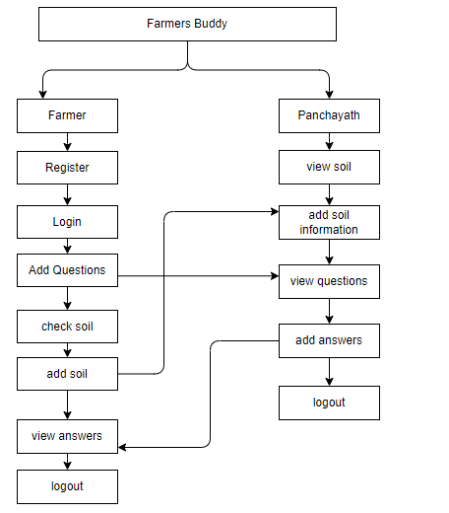

**4. REQUIREMENT ANALYSIS**

**4.1 Functional and non-functional requirements**

Requirement’s analysis is very critical process that enables the success of a system or software project to be assessed. Requirements are generally split into two types: Functional and non-functional requirements.

**Functional Requirements**: These are the requirements that the end user specifically demands as basic facilities that the system should offer. All these functionalities need to be necessarily incorporated into the system as a part of the contract. These are represented or stated in the form of input to be given to the system, the operation performed and the output expected. They are basically the requirements stated by the user which one can see directly in the final product, unlike the non-functional requirements.

Examples of functional requirements:

1. Authentication of user whenever he/she logs into the system
2. System shutdown in case of a cyber-attack
3. A verification email is sent to user whenever he/she register for the first time on some software system.

**Non-functional requirements**: These are basically the quality constraints that the system must satisfy according to the project contract. The priority or extent to which these factors are implemented varies from one project to other. They are also called non-behavioral requirements.  
They basically deal with issues like:

* Portability
* Security
* Maintainability
* Reliability
* Scalability
* Performance
* Reusability
* Flexibility

Examples of non-functional requirements:

1. Emails should be sent with a latency of no greater than 12 hours from such an activity.
2. The processing of each request should be done within 10 seconds
3. The site should load in 3 seconds whenever of simultaneous users are > 10000
   1. **Hardware Requirements**

# Processor : - I3/Intel Processor

# Operating System : Windows 7/8/10

# Server side Script : react, CSS, Bootstrap & JS

# Programming Language : java

# Libraries : Node

# IDE/Workbench : Intellij

* 1. **Software Requirements:**

Technology : java

Server Deployment : tomcat Server

Database : mongo dB

**Architecture:**

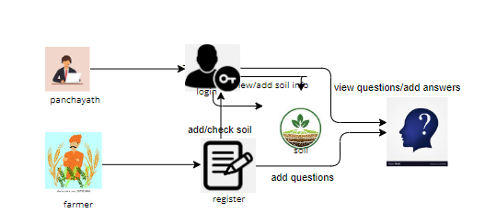

**5. SYSTEM DESIGN**

**5.1 Introduction of Input Design:**

In an information system, input is the raw data that is processed to produce output. During the input design, the developers must consider the input devices such as PC, MICR, OMR, etc.

Therefore, the quality of system input determines the quality of system output. Well-designed input forms and screens have following properties −

* It should serve specific purpose effectively such as storing, recording, and retrieving the information.
* It ensures proper completion with accuracy.
* It should be easy to fill and straightforward.
* It should focus on user’s attention, consistency, and simplicity.
* All these objectives are obtained using the knowledge of basic design principles regarding −
  + What are the inputs needed for the system?
  + How end users respond to different elements of forms and screens.

### **Objectives for Input Design:**

The objectives of input design are −

* To design data entry and input procedures
* To reduce input volume
* To design source documents for data capture or devise other data capture methods
* To design input data records, data entry screens, user interface screens, etc.
* To use validation checks and develop effective input controls.

**Output Design:**

The design of output is the most important task of any system. During output design, developers identify the type of outputs needed, and consider the necessary output controls and prototype report layouts.

### Objectives of Output Design:

The objectives of input design are:

* To develop output design that serves the intended purpose and eliminates the production of unwanted output.
* To develop the output design that meets the end user’s requirements.
* To deliver the appropriate quantity of output.
* To form the output in appropriate format and direct it to the right person.
* To make the output available on time for making good decisions.

**5.2 UML Diagrams:**

**5.2.1 Use Case Diagram:**

A use case diagram in the Unified Modeling Language (UML) is a type of behavioral diagram defined by and created from a Use-case analysis. Its purpose is to present a graphical overview of the functionality provided by a system in terms of actors, their goals (represented as use cases), and any dependencies between those use cases. The main purpose of a use case diagram is to show what system functions are performed for which actor. Roles of the actors in the system can depicted.

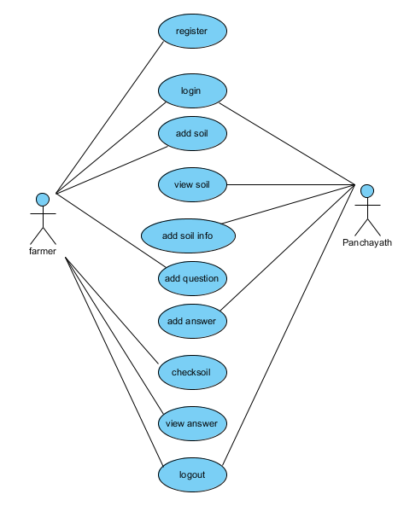

**5.2.2 Class Diagram:**

In software engineering, a class diagram in the Unified Modelling Language (UML) is a type of static structure diagram that describes the structure of a system by showing the system's classes, their attributes, operations (or methods), and the relationships among the classes. It explains which class contains information.

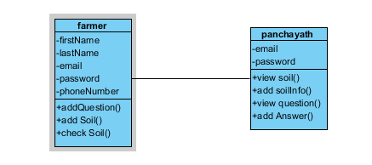

**5.2.3 Sequence Diagram:**

A sequence diagram in Unified Modelling Language (UML) is a kind of interaction diagram that shows how processes operate with one another and in what order. It is a construct of a Message sequence Chart. Sequence diagrams are sometimes called event diagrams, event scenarios, and

Event timings.

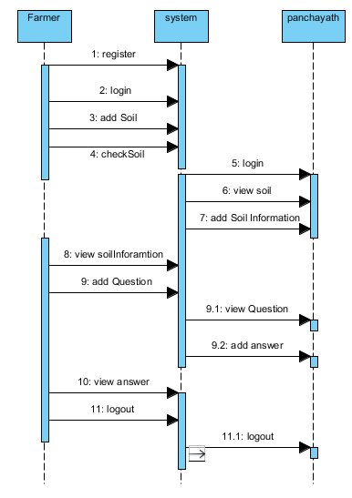

.

**5.2.4 Collaboration Diagram:**

In collaboration diagram the method call sequence is indicated by some numbering technique as shown below. The number indicates how the methods are called one after another. We have taken the same order management system to describe the collaboration diagram. The method calls are similar to that of a sequence diagram. But the difference is that the sequence diagram does not describe the object organization whereas the collaboration diagram shows the object organization.

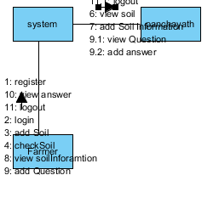

**5.2.5 Deployment Diagram**

Deployment diagram represents the deployment view of a system. It is related to the component diagram. Because the components are deployed using the deployment diagrams. A deployment diagram consists of nodes. Nodes are nothing but physical hardware’s used to deploy the application.

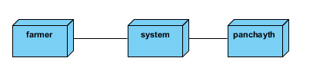

**5.2.6 Activity Diagram:**

Activity diagrams are graphical representations of workflows of stepwise activities and actions with support for choice, iteration and concurrency. In the Unified Modelling Language, activity diagrams can be used to describe the business and operational step-by-step workflows of components in a system. An activity diagram shows the overall flow of control.

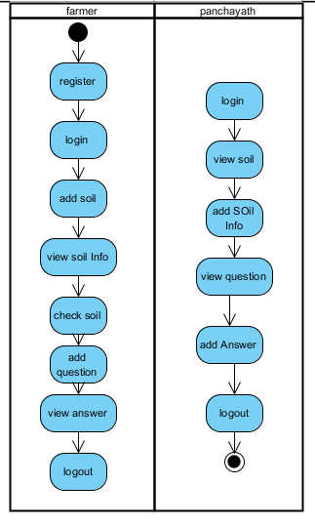

**5.2.7 Component Diagram**:

A component diagram, also known as a UML component diagram, describes the organization and wiring of the physical **c**omponents in a system. Component diagrams are often drawn to help model implementation details and double-check that every aspect of the system's required functions is covered by planned development.

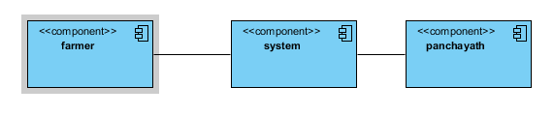

**5.2.8 ER Diagram:**

An Entity–relationship model (ER model) describes the structure of a database with the help of a diagram, which is known as Entity Relationship Diagram (ER Diagram). An ER model is a design or blueprint of a database that can later be implemented as a database. The main components of E-R model are: entity set and relationship set.

An ER diagram shows the relationship among entity sets. An entity set is a group of similar entities and these entities can have attributes. In terms of DBMS, an entity is a table or attribute of a table in database, so by showing relationship among tables and their attributes, ER diagram shows the complete logical structure of a database. Let’s have a look at a simple ER diagram to understand this concept.

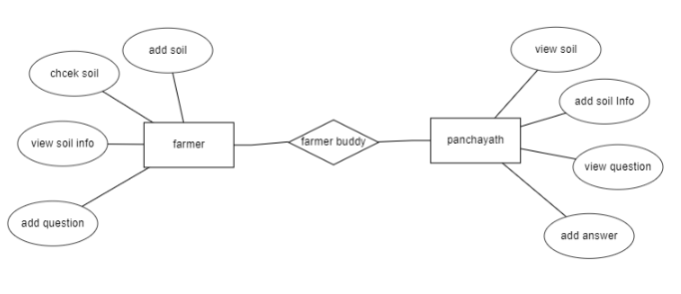

**5.3 DFD Diagram:**

A Data Flow Diagram (DFD) is a traditional way to visualize the information flows within a system. A neat and clear DFD can depict a good amount of the system requirements graphically. It can be manual, automated, or a combination of both. It shows how information enters and leaves the system, what changes the information and where information is stored. The purpose of a DFD is to show the scope and boundaries of a system as a whole. It may be used as a communications tool between a systems analyst and any person who plays a part in the system that acts as the starting point for redesigning a system.

**Context level:**

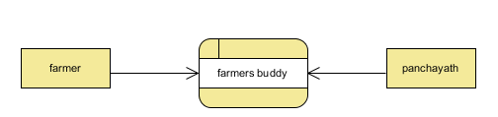

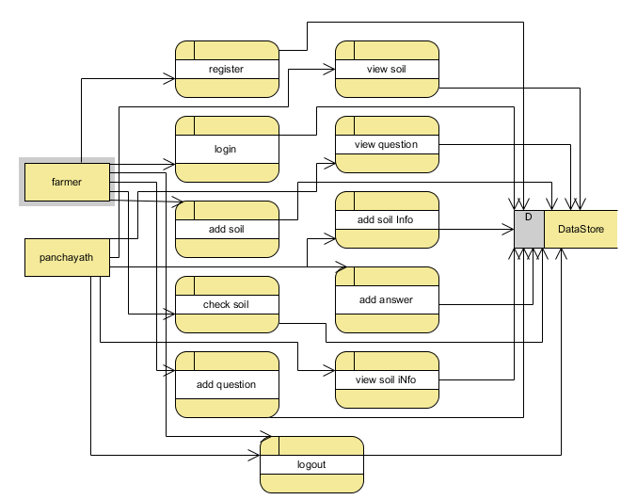

**Level 2 Diagram:**

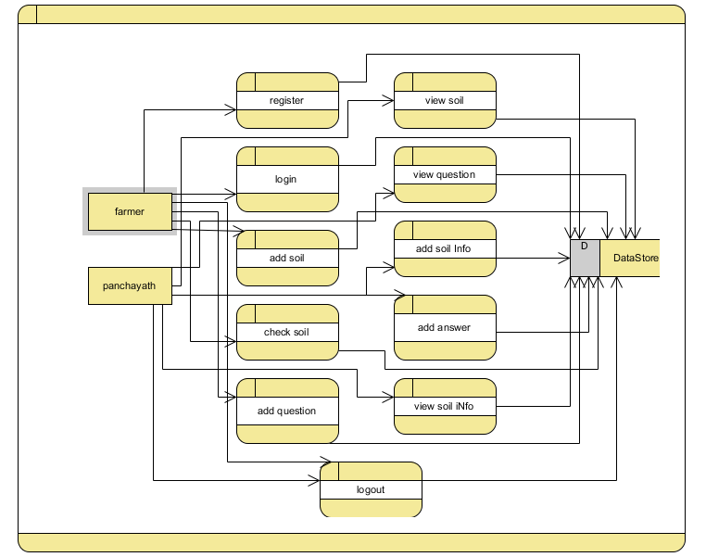

**IMPLEMENTATION AND RESULTS**

**6.1 Modules:**

**Farmer:**

Operation-**Register:** Farmer will register into the application by entering the valid details like (first Name, last Name ,phone number , email Address and password).

Operation-**Login:** Admin will login into the application by entering the valid details like (username and password).

Operation-**Manage Soil:** Add & Check

**Add Soil:** Farmer will add the soil with their details like(soil type, season, phosporous content ,nitrogen content , fertilizer per year , cost ).

**Add Question:** Farmer will add the questions with their details like(question)

**Check Soil:** The Famer will check the soil by giving the type of the soil and season.

Operation - **Sign out :** After completion of work he/she can logout the application.

**Panchayath :** Panchayathcan access the application by entering their login information

Operation - **Sign in:** Panchayathcan access the application by entering their login information (default login credentials like username and password )

Operations -**View Soil:** He/she will see the soil details and add some information about the soil

Operations -**View Question:** He/she will see the questions raised by the farmer and add answers to that question.

Operation - **Sign out :** After completion of work he/she can logout the application.

**6.2 Results:**

Home page: This is Farmers buddy home page.

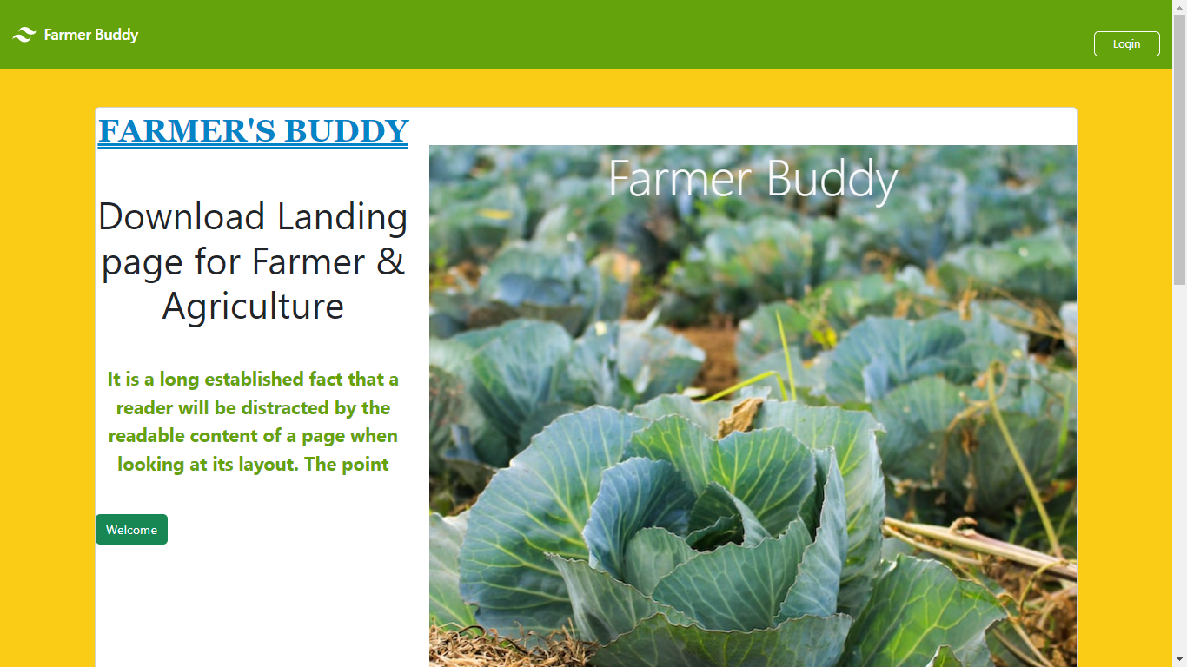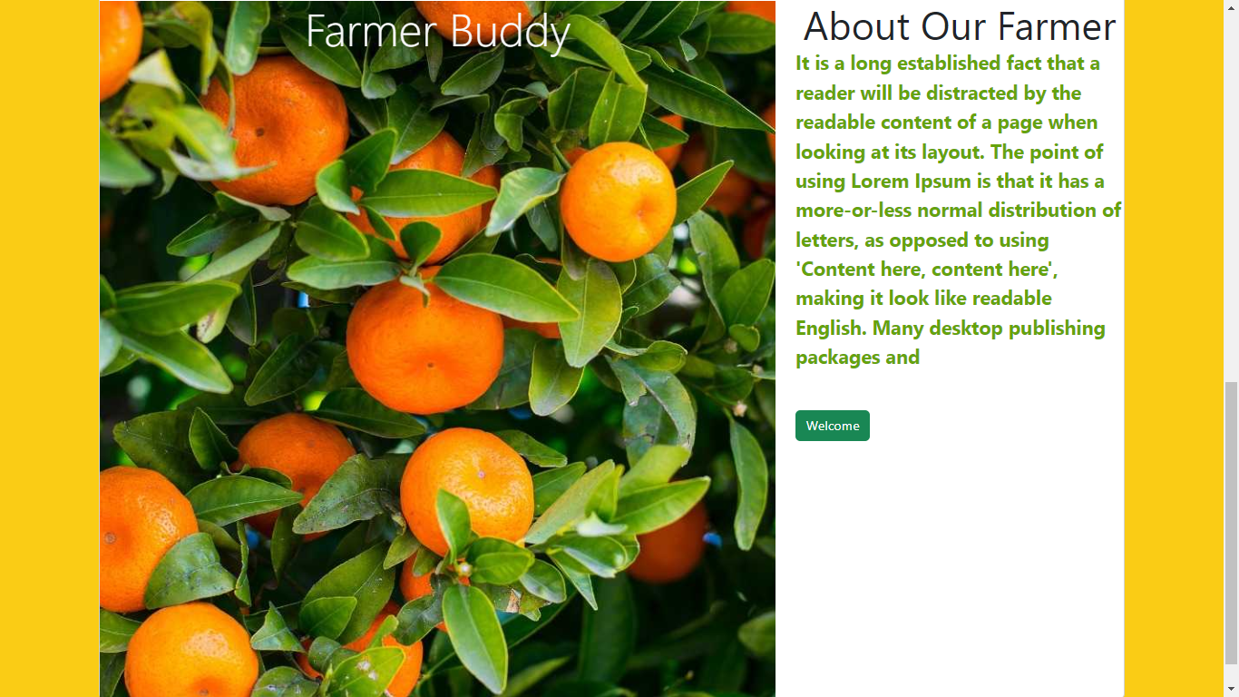

Farmer, Panchayat Login Page: This is the farmer ,Panchayat login page.

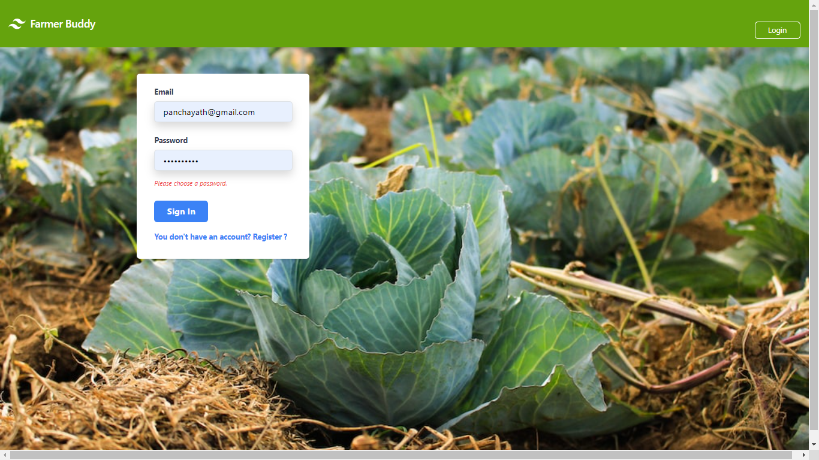

Farmer Register page: This is farmers registration page:

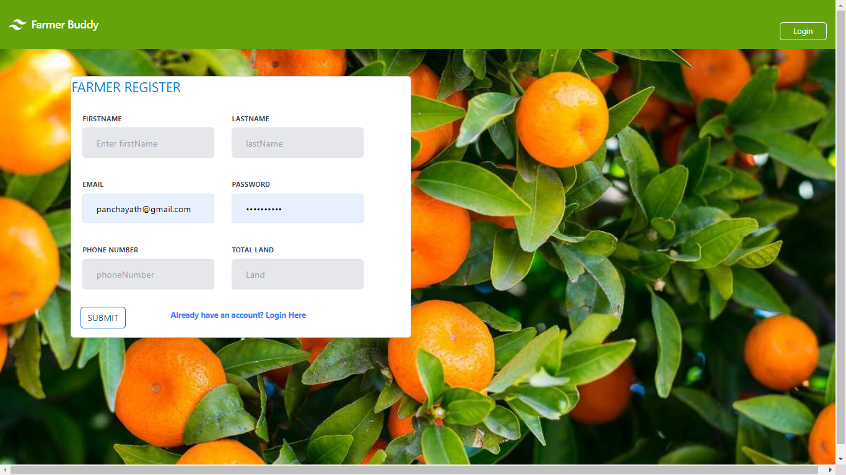

Farmers Home Page: This is Farmers home page:

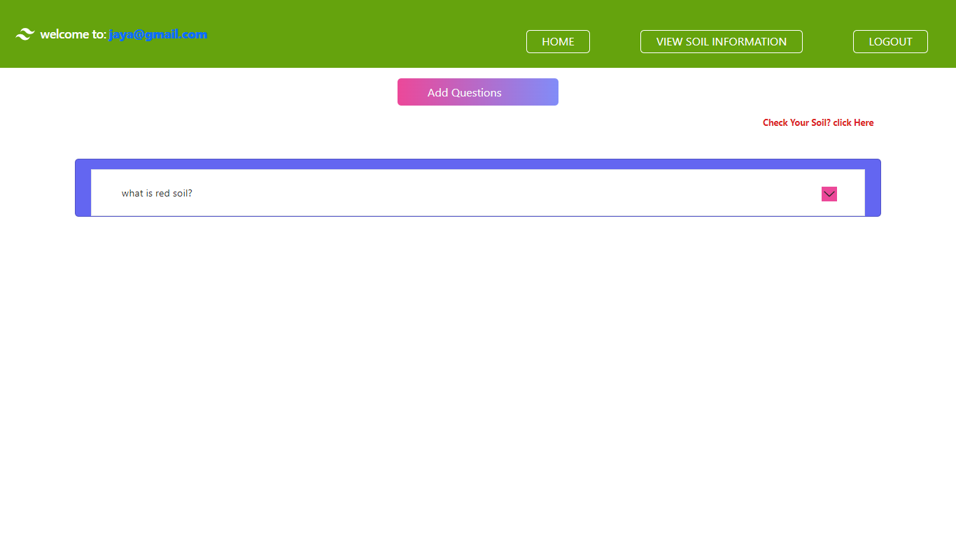

Add Question: Farmer can add questions regarding to farming

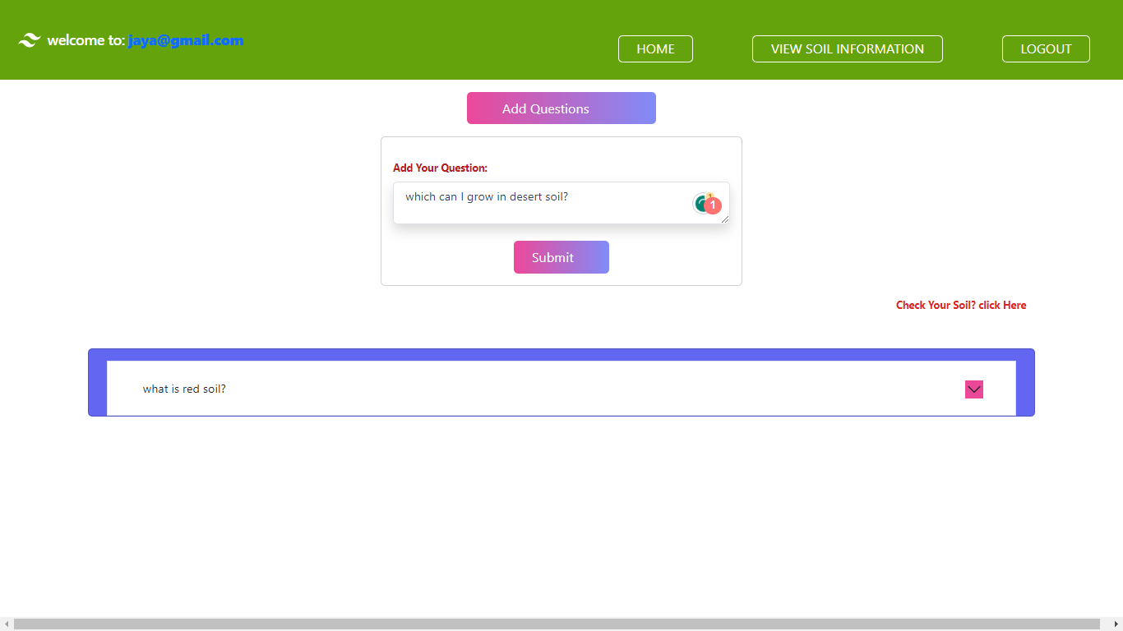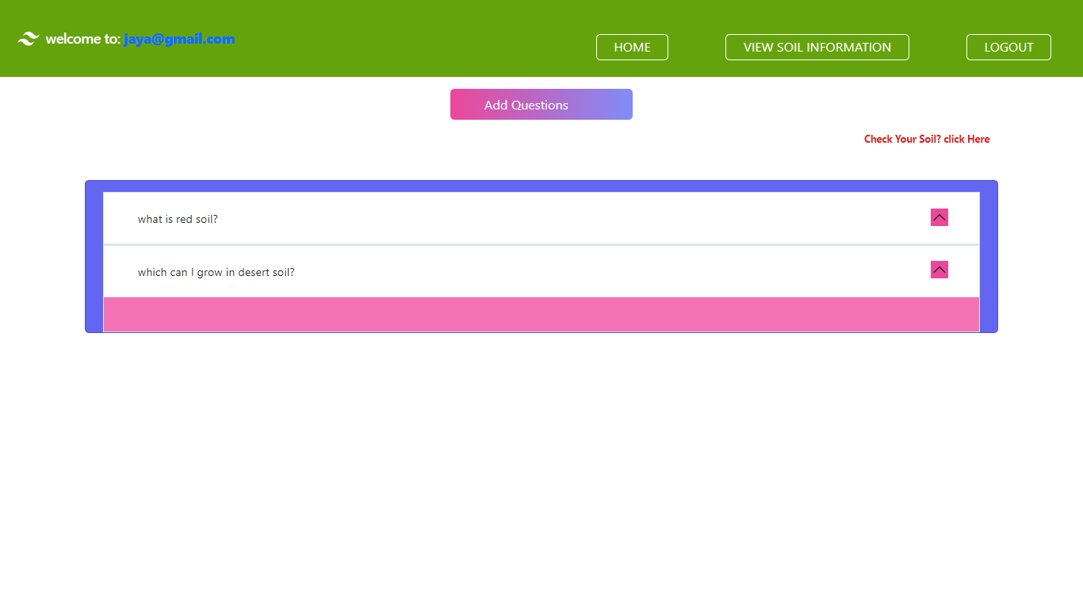

**Check soil:** Farmer can check their soil by giving season and type of the soil:

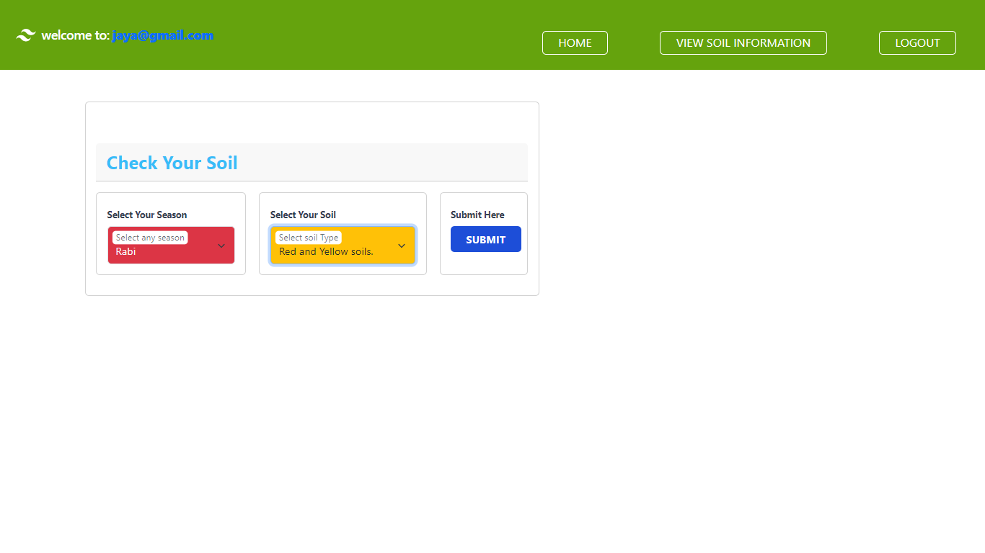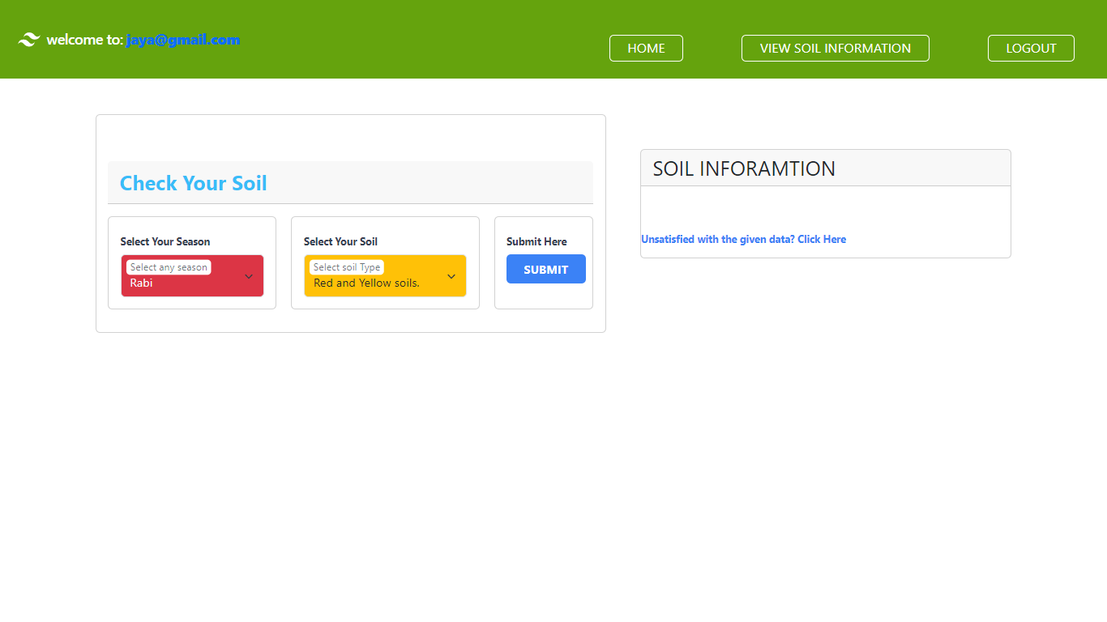  
Add Soil: Add soil information

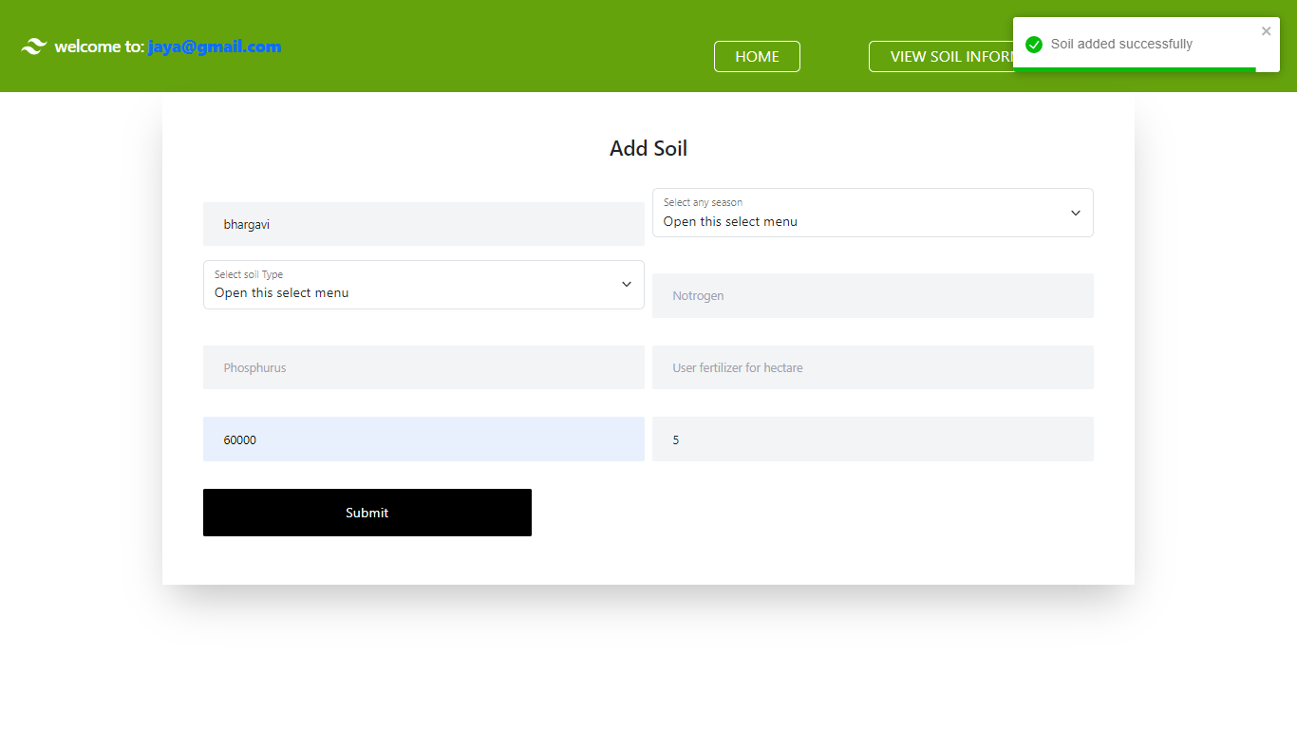

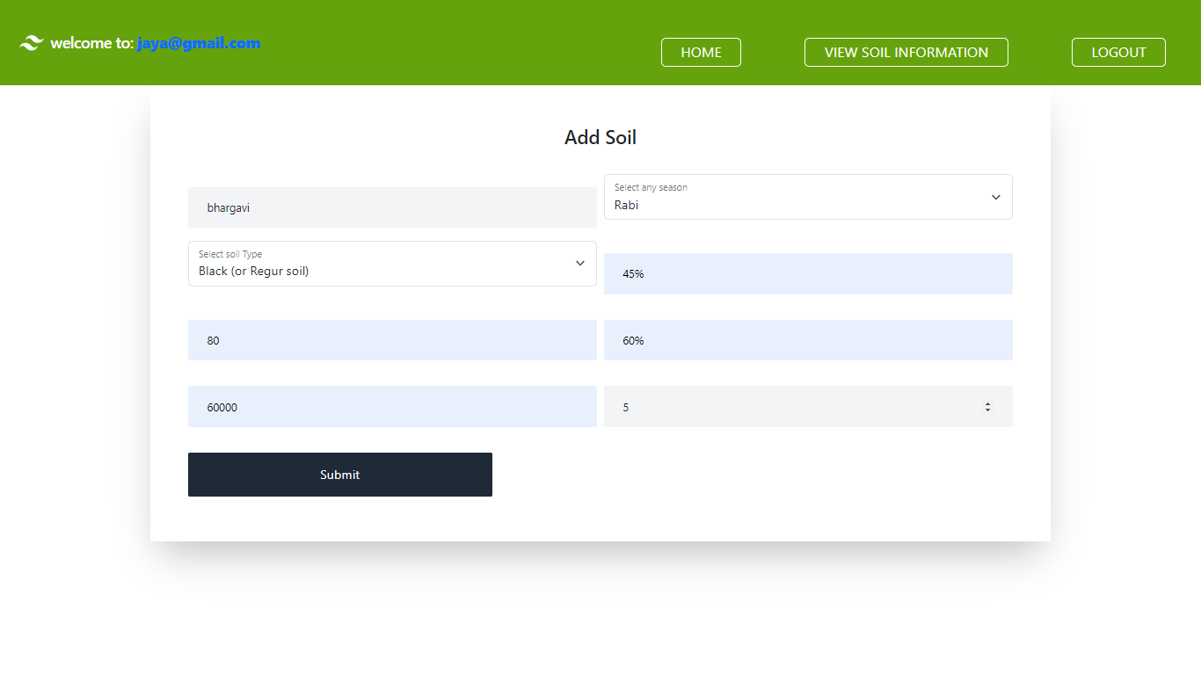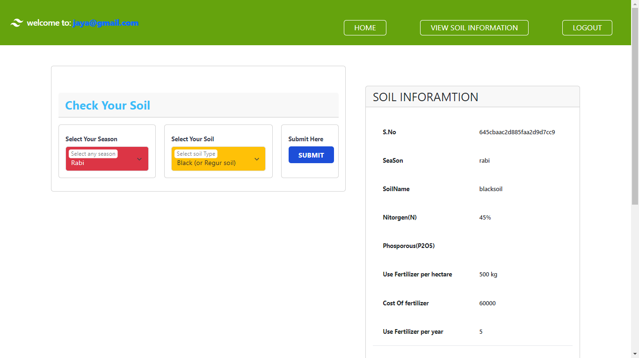

Panchayath Login: This is Panchayath login page:

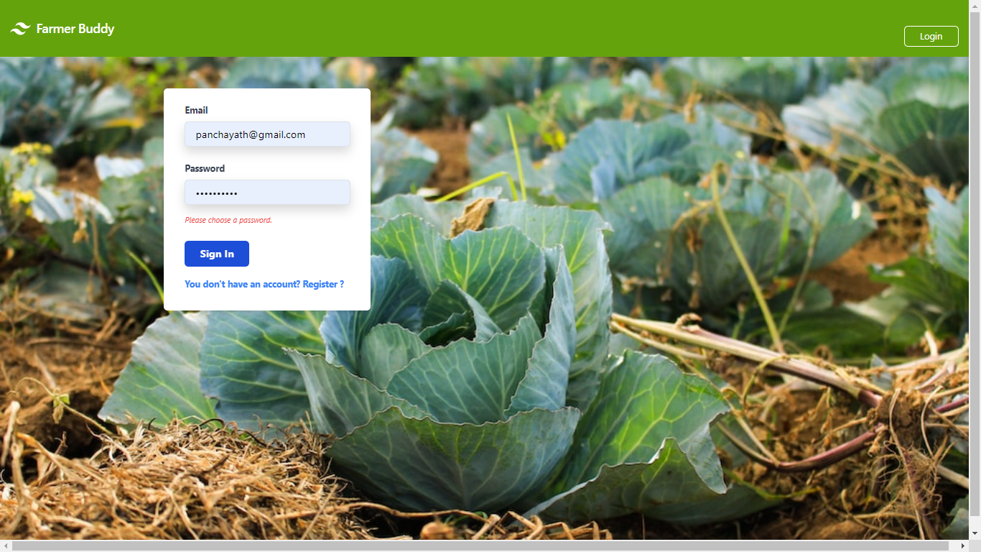

View Soil: Panchayat can view soils added by the farmer

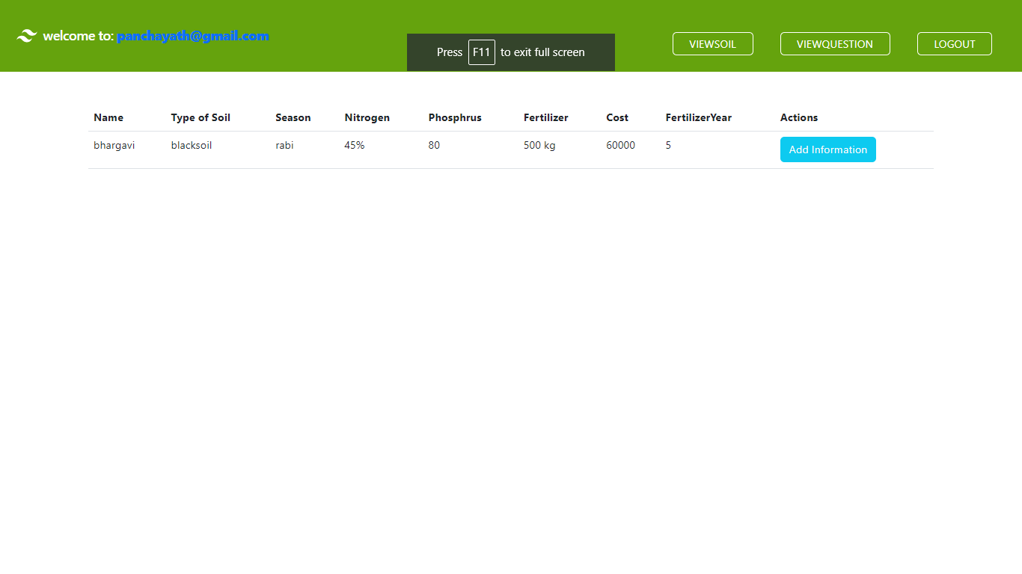

Add Information: Panchayath can add information about the soil

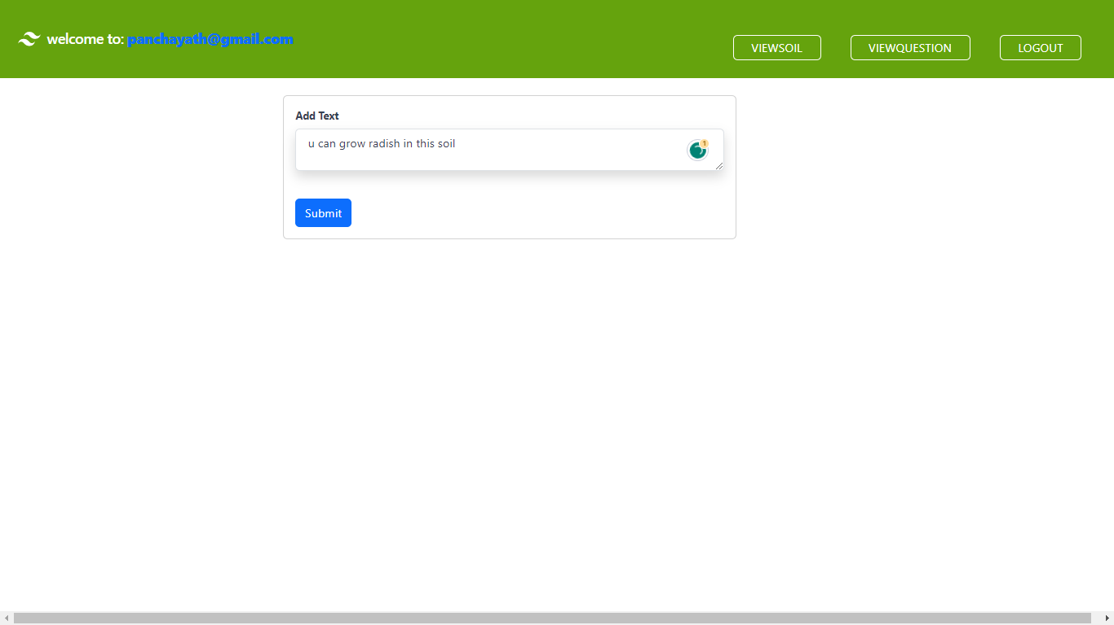

Add Answer: Panchayath can add the answer related to the question added by the frmer

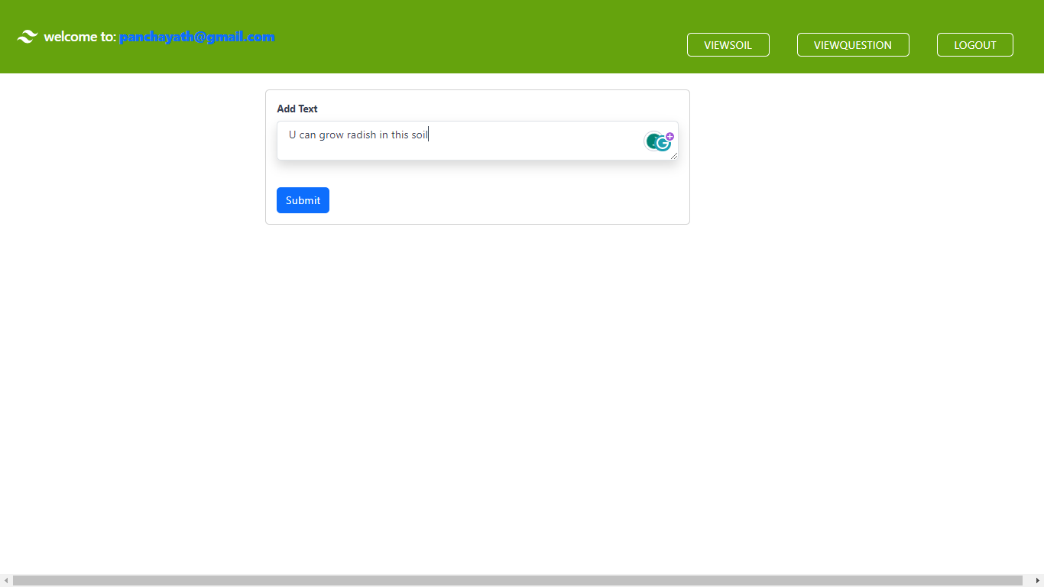

View Soil Information : Farmer can view the soil Information added by the panchayath

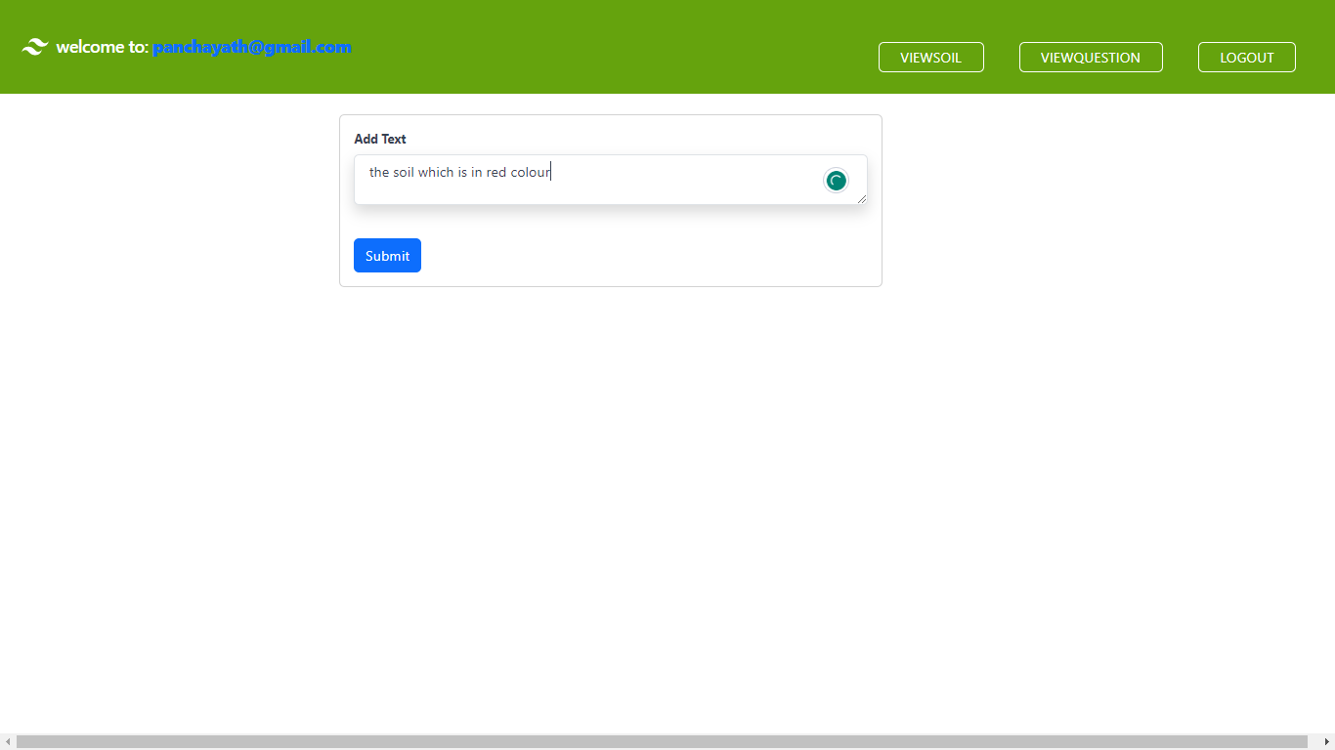  
View Answer: Farmer can view the answer added by the panchayth

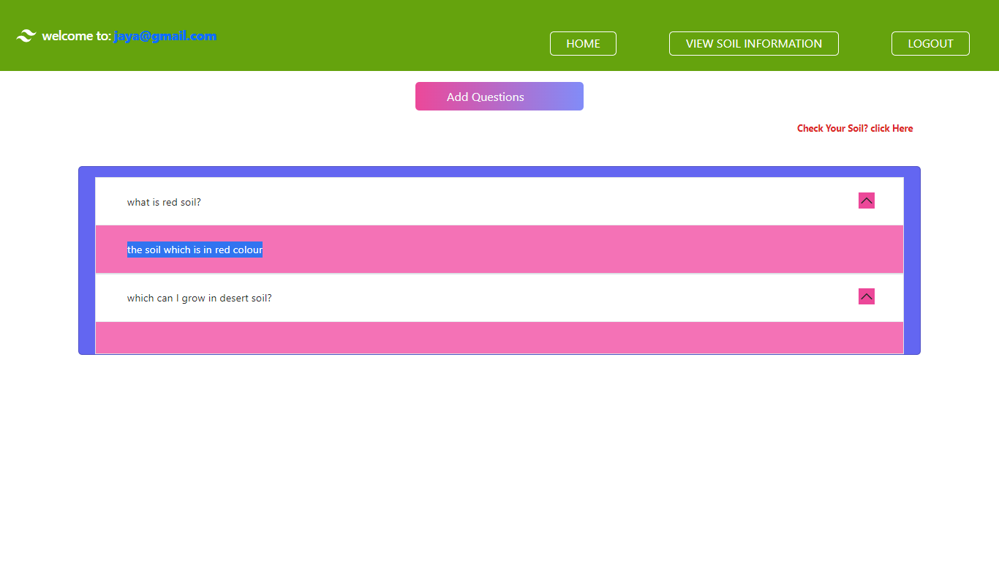

View Information: Farmer can view the information added by the panchayath

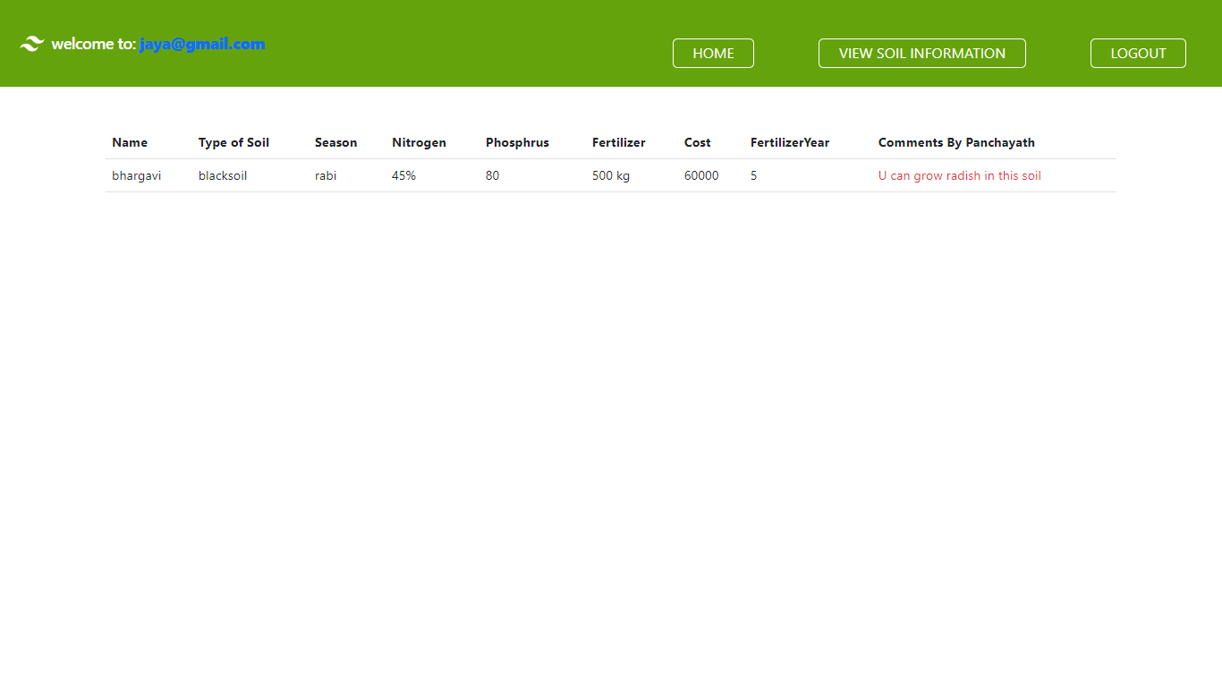

**SOFTWARE INSTALLATION FOR JAVA PROJECTS**

This Java Development Kit(JDK) allows you to code and run Java programs. It's possible that you install multiple JDK versions on the same PC. But It’s recommended that you install only latest version.

## How to install Java for Windows

Following are the steps for JDK 8 free download for 32 bit or JDK 8 download 64 bit and installation

**Step 1)** Go to [link](https://www.oracle.com/java/technologies/javase-downloads.html). Click on JDK Download for Java

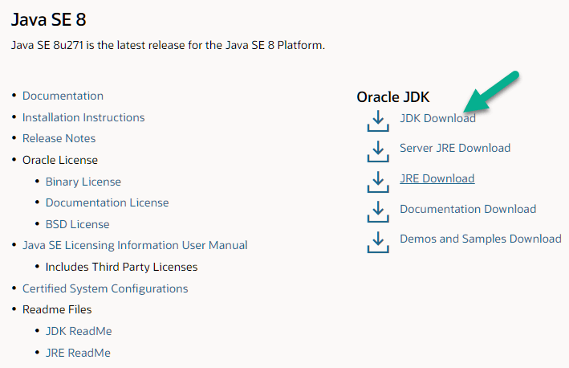

**Step 2)** Next,

1. Accept License Agreement
2. Download Java 8 JDK for your version 32 bit or JDK 8 download for windows 10 64 bit.

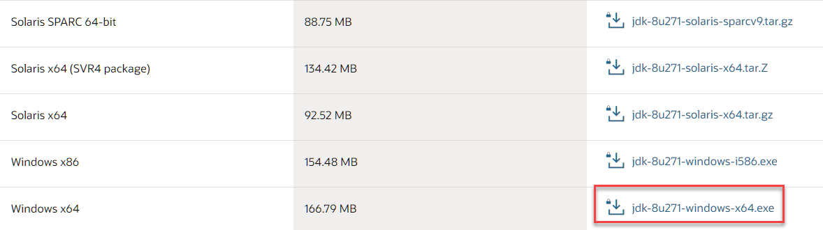

**Step 3)** when you click on the Installation link the popup will be open. Click on I reviewed and accept the Oracle Technology Network License Agreement for Oracle Java SE and you will be redirected to the login page. If you don't have an oracle account you can easily sign up by adding basics details of yours.

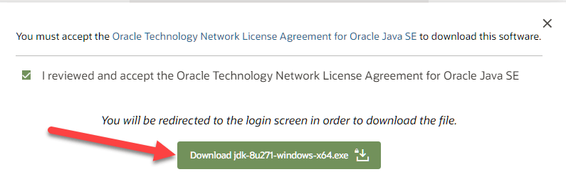

**Step 4)** Once the Java JDK 8 download is complete, run the exe for install JDK. Click Next

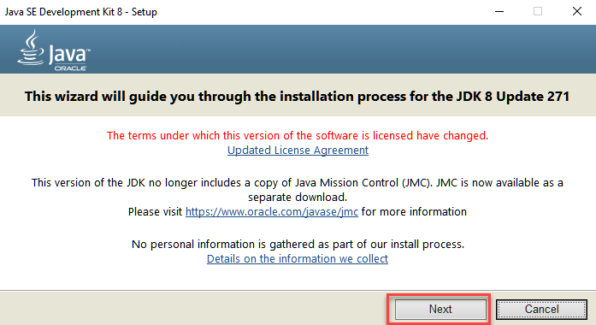

**Step 5)** Select the PATH to install Java in Windows and click next.

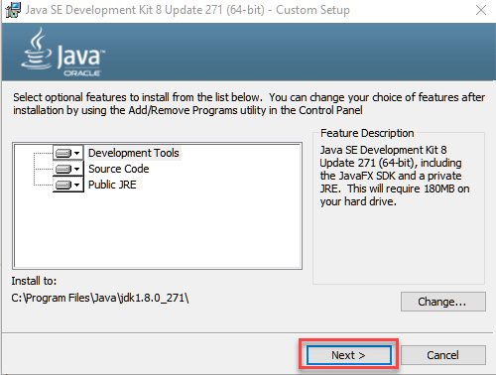

**Step 6)** Once you install Java in windows, click close

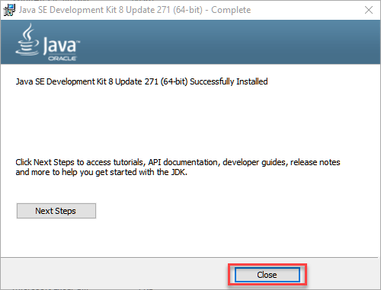

## How to set Environment Variables in Java: Path and Class path

The PATH variable gives the location of executable like javac, java etc. It is possible to run a program without specifying the PATH but you will need to give full path of executable like **C:\Program Files\Java\jdk-13.0.1\bin\javac A.java** instead of simple **javac A.java**

The CLASSPATH variable gives location of the Library Files.

Let's look into the steps to set the PATH and CLASSPATH

**Step 1)** Right Click on the My Computer and Select the properties

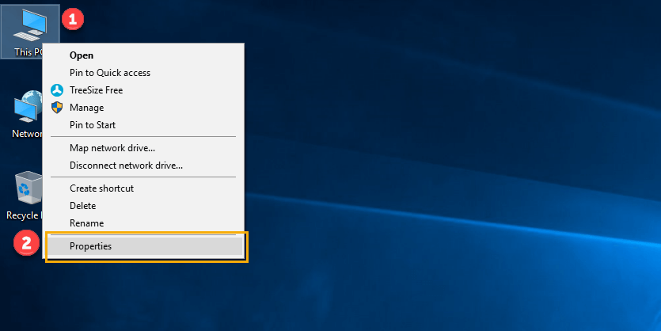

**Step 2)** Click on advanced system settings

**Step 3)** Click on Environment Variables

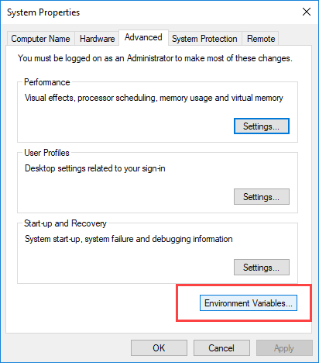

**Step 4)** Click on new Button of User variables

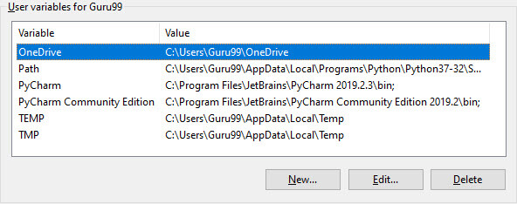

**Step 5)** Type PATH in the Variable name.

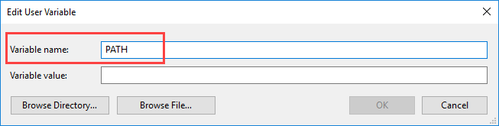

**Step 6)** Copy the path of bin folder which is installed in JDK folder.

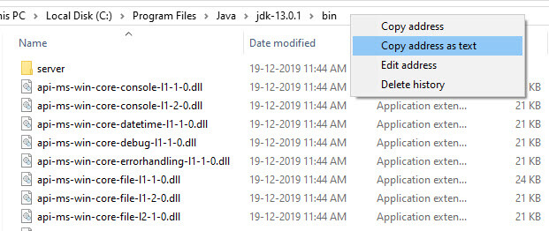

**Step 7)** Paste Path of bin folder in Variable value and click on OK Button.

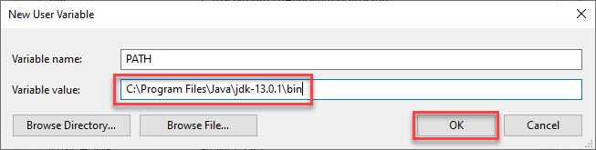

**Note:** In case you already have a PATH variable created in your PC, edit the PATH variable to

PATH = <JDK installation directory>\bin;%PATH%;

Here, %PATH% appends the existing path variable to our new value

**Step 8)**You can follow a similar process to set CLASSPATH.

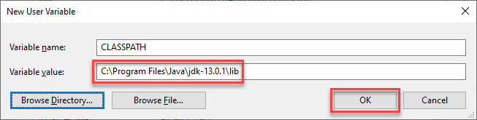

**Note:** In case you java installation does not work after installation, change classpath to

CLASSPATH = <JDK installation directory>\lib\tools.jar;

**Step 9)** Click on OK button

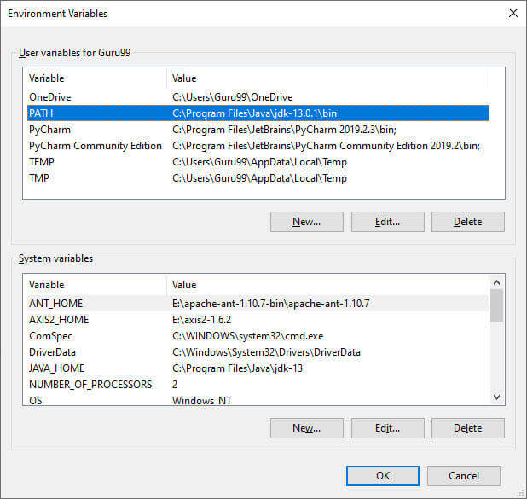

**Step 10)** Go to command prompt and type javac commands.

If you see a screen like below, Java is installed.

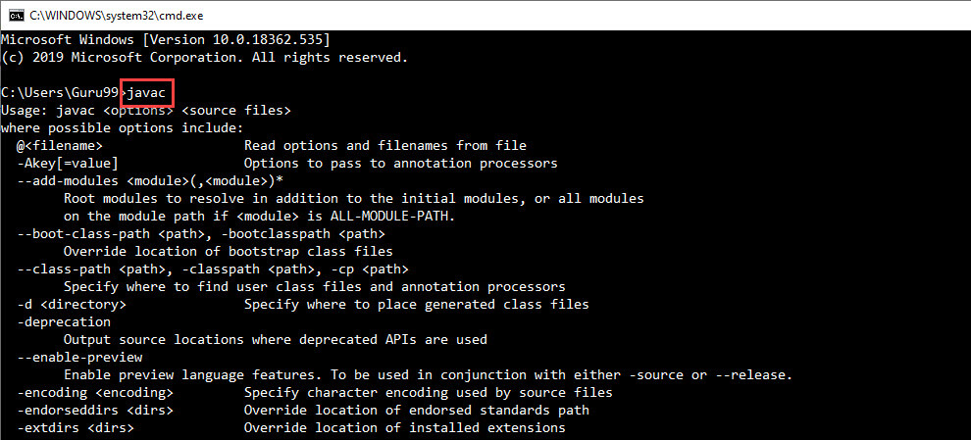

**INSTALLING JAVA AND INTELLIJ IDEA**

**Installing java:**

This Java Development Kit(JDK) allows you to code and run Java programs. It's possible that you install multiple JDK versions on the same PC. But It’s recommended that you install only latest version.

## How to install Java for Windows

Following are the steps for JDK 8 free download for 32 bit or JDK 8 download 64 bit and installation

**Step 1)** Go to [link](https://www.oracle.com/java/technologies/javase-downloads.html). Click on JDK Download for Java



**Step 2)** Next,

1. Accept License Agreement
2. Download Java 8 JDK for your version 32 bit or JDK 8 download for windows 10 64 bit.



**Step 3)** when you click on the Installation link the popup will be open. Click on I reviewed and accept the Oracle Technology Network License Agreement for Oracle Java SE and you will be redirected to the login page. If you don't have an oracle account you can easily sign up by adding basics details of yours.



**Step 4)** once the Java JDK 8 download is complete, run the exe for install JDK. Click Next



**Step 5)** Select the PATH to install Java in Windows and click next.



**Step 6)** Once you install Java in windows, click close



## How to set Environment Variables in Java: Path and Class path

The PATH variable gives the location of executable like javac, java etc. It is possible to run a program without specifying the PATH but you will need to give full path of executable like **C:\Program Files\Java\jdk-13.0.1\bin\javac A.java** instead of simple **javac A.java**

The CLASSPATH variable gives location of the Library Files.

Let's look into the steps to set the PATH and CLASSPATH

**Step 1)** Right Click on the My Computer and Select the properties



**Step 2)** Click on advanced system settings

**Step 3)** Click on Environment Variables



**Step 4)** Click on new Button of User variables



**Step 5)** Type PATH in the Variable name.



**Step 6)** Copy the path of bin folder which is installed in JDK folder.



**Step 7)** Paste Path of bin folder in Variable value and click on OK Button.



**Note:** In case you already have a PATH variable created in your PC, edit the PATH variable to

PATH = <JDK installation directory>\bin;%PATH%;

Here, %PATH% appends the existing path variable to our new value

**Step 8)**You can follow a similar process to set CLASSPATH.



**Note:** In case you java installation does not work after installation, change classpath to

CLASSPATH = <JDK installation directory>\lib\tools.jar;

**Step 9)** Click on OK button



**Step 10)** Go to command prompt and type javas commands.

If you see a screen like below, Java is installed.



Installing intellij idea:

1. To download Intellij visit the website https://www.jetbrains.com/idea/download/#section=windows and Click the "DOWNLOAD" link under the Community Section.

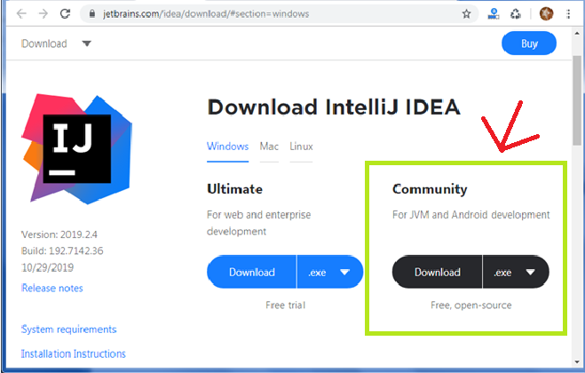

1. Once the download is complete, run the exe for install Intellij. The setup wizard should have started. Click “Next”.
2. On the next screen, Change the installation path if required. Click “Next”.
3. On the next screen, you can create a desktop shortcut if you want and click on “Next”.
4. Choose the start menu folder. Keep selected Jet Brains and click on “Install”.
5. Wait for the installation to finish.
6. Once installation finished, you should receive a message screen that Intellij is installed. If you want to go ahead and run it, click the “Run Intellij Community Edition” box first and click “Finish”.
7. After you click on "Finish," the Following screen will appear.

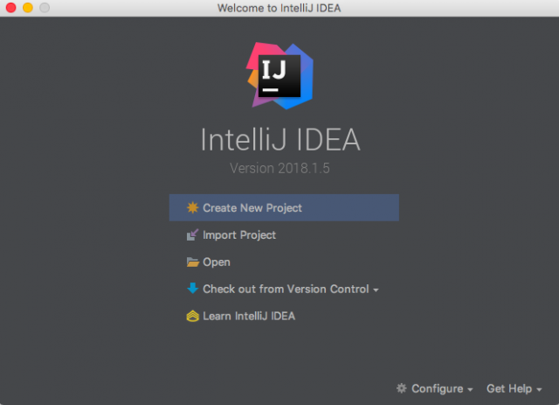

**Installing visual studio code**

Steps to installing visual studio code:

Step 1: Head over to the website <https://code.visualstudio.com/download>

Step2:choose the option as per your choice.

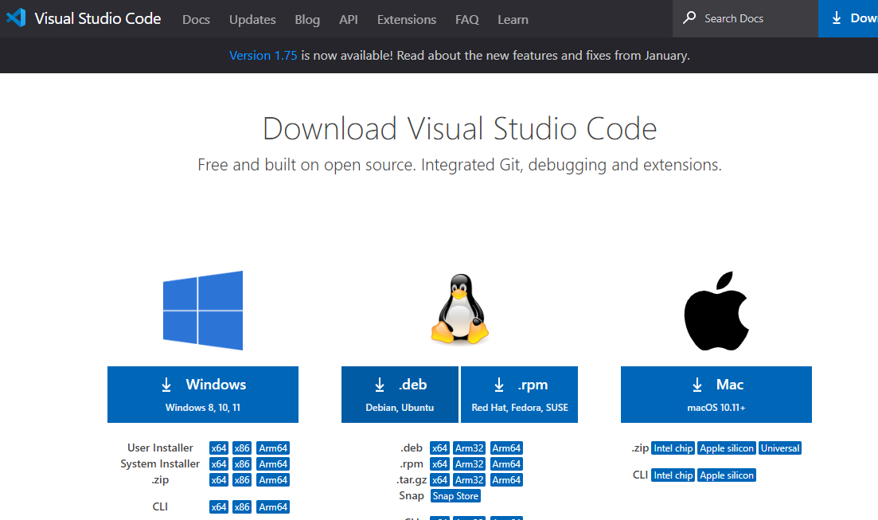

Step 3: Once download completed,open it and your screen will appear like this

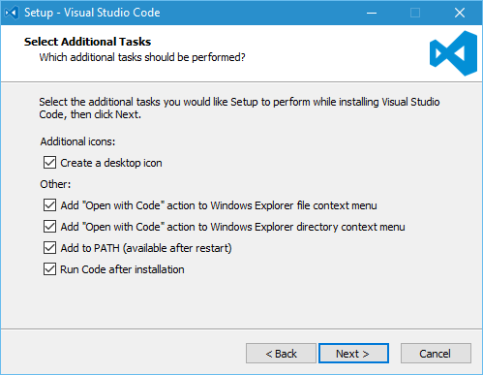

Step 4: click next until you saw the below page

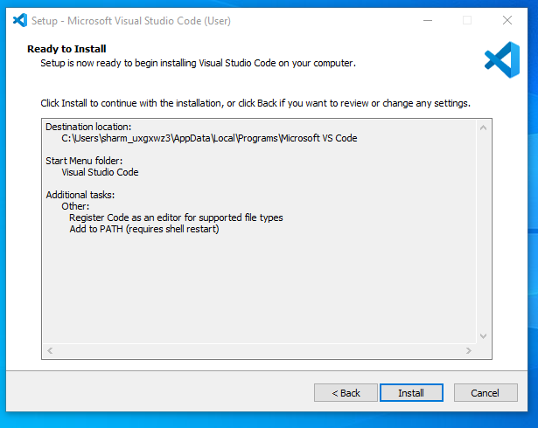

Step 4: After installation your screen will appear like this ,click finish and continue.

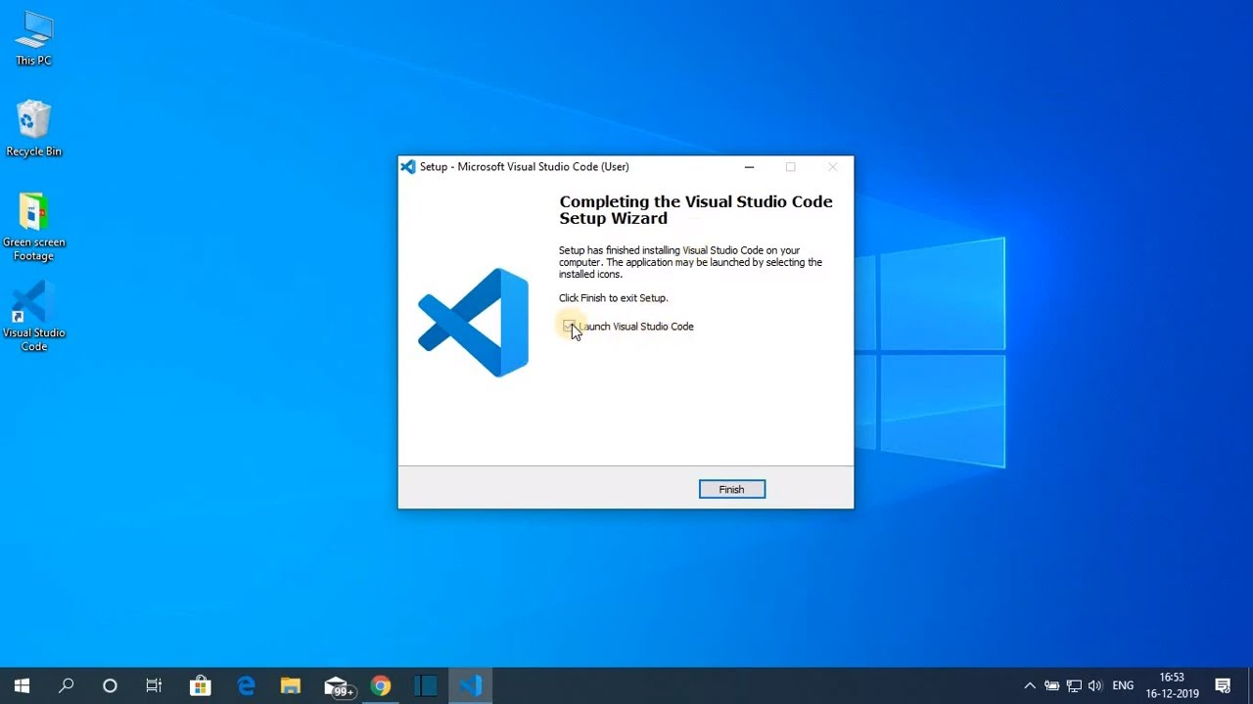

**Installing MongoDB**

**Step 1)**Download MongoDB Community Server

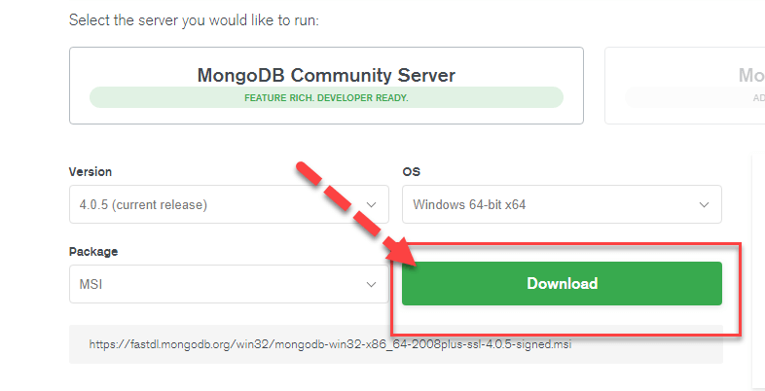

**Step 2)** Click on Setup

Once download is complete open the msi file. Click Next in the start up screen

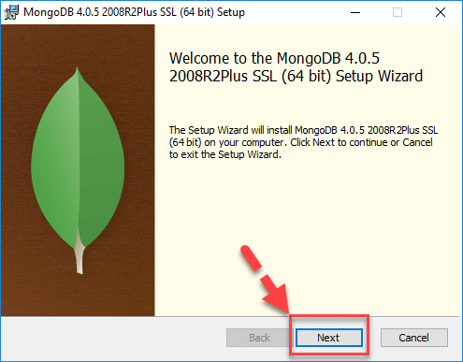

**Step 3)** Accept the End-User License Agreement

1. Accept the End-User License Agreement
2. Click Next

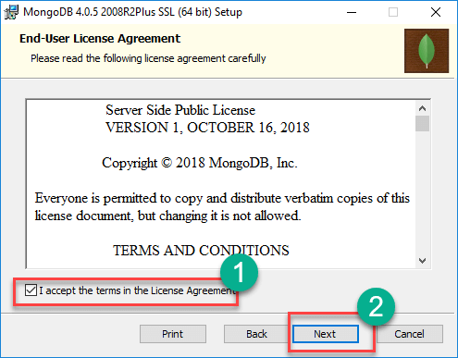

**Step 4)** Click on the “complete” button

Click on the “complete” button to install all of the components. The custom option can be used to install selective components or if you want to change the location of the installation.

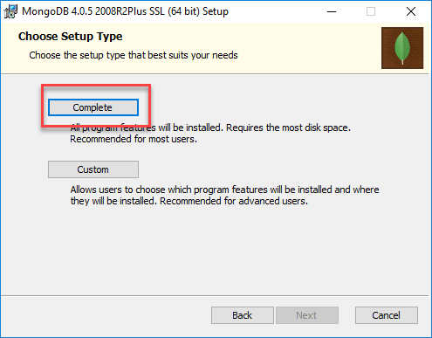

**Step 5)** Service Configuration

1. Select “Run service as Network Service user”. make a note of the data directory, we’ll need this later.
2. Click Next

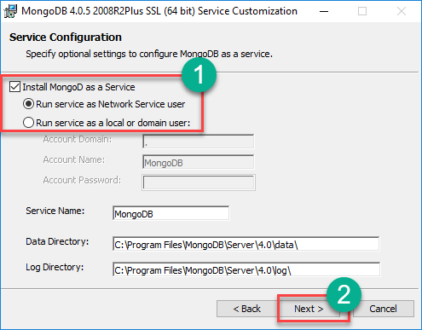

**Step 6)** Start installation process

Click on the Install button to start the installation.

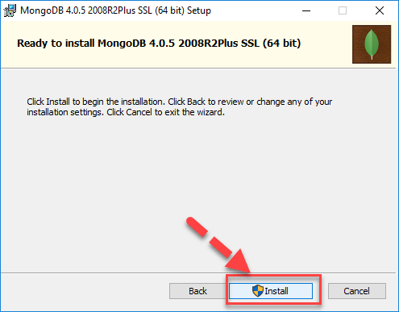

**Step 7)** Click Next once completed

Installation begins. Click Next once completed

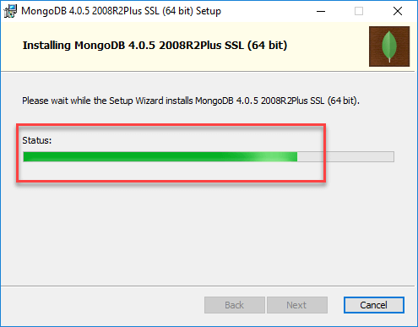

**Step 8)** Click on the Finish button

Final step, Once complete the installation, Click on the Finish button

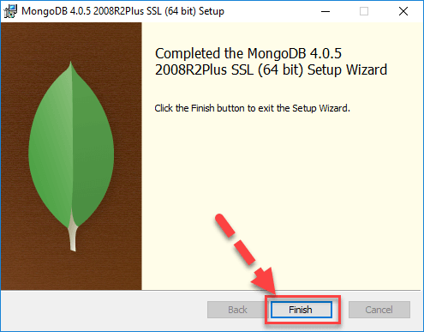

Step 16:click on finish.

**8. SYSTEM STUDY AND TESTING**

**8.1 Feasibility Study**

The feasibility of the project is analysed in this phase and business proposal is put forth with a very general plan for the project and some cost estimates. During system analysis the feasibility study of the proposed system is to be carried out. This is to ensure that the proposed system is not a burden to the company. For feasibility analysis, some understanding of the major requirements for the system is essential.

Three key considerations involved in the feasibility analysis are

* Economical feasibility
* Technical feasibility
* Social feasibility

**Economical Feasibility**

This study is carried out to check the economic impact that the system will have on the organization. The amount of fund that the company can pour into the research and development of the system is limited. The expenditures must be justified. Thus the developed system as well within the budget and this was achieved because most of the technologies used are freely available. Only the customized products had to be purchased.

### **Technical Feasibility**

This study is carried out to check the technical feasibility, that is, the technical requirements of the system. Any system developed must not have a high demand on the available technical resources. This will lead to high demands on the available technical resources. This will lead to high demands being placed on the client. The developed system must have a modest requirement, as only minimal or null changes are required for implementing this system.

**Social Feasibility**

The aspect of study is to check the level of acceptance of the system by the user. This includes the process of training the user to use the system efficiently. The user must not feel threatened by the system, instead must accept it as a necessity. The level of acceptance by the users solely depends on the methods that are employed to educate the user about the system and to make him familiar with it. His level of confidence must be raised so that he is also able to make some constructive criticism, which is welcomed, as he is the final user of the system.

### **System Testing**

The purpose of testing is to discover errors. Testing is the process of trying to discover every conceivable fault or weakness in a work product. It provides a way to check the functionality of components, sub-assemblies, assemblies and/or a finished product It is the process of exercising software with the intent of ensuring that the

Software system meets its requirements and user expectations and does not fail in an unacceptable manner. There are various types of test. Each test type addresses a specific testing requirement.

**8.2 Types of Tests**

**8.2.1 Unit testing**

Unit testing involves the design of test cases that validate that the internal program logic is functioning properly, and that program inputs produce valid outputs. All decision branches and internal code flow should be validated. It is the testing of individual software units of the application .it is done after the completion of an individual unit before integration. This is a structural testing, that relies on knowledge of its construction and is invasive. Unit tests perform basic tests at component level and test a specific business process, application, and/or system configuration. Unit tests ensure that each unique path of a business process performs accurately to the documented specifications and contains clearly defined inputs and expected results.

**8.2.2 Integration testing**

Integration tests are designed to test integrated software components to determine if they actually run as one program. Testing is event driven and is more concerned with the basic outcome of screens or fields. Integration tests demonstrate that although the components were individually satisfaction, as shown by successfully unit testing, the combination of components is correct and consistent. Integration testing is specifically aimed at exposing the problems that arise from the combination of components.

Software integration testing is the incremental integration testing of two or more integrated software components on a single platform to produce failures caused by interface defects.

The task of the integration test is to check that components or software applications, e.g. components in a software system or – one step up – software applications at the company level – interact without error.

**Test Results:** All the test cases mentioned above passed successfully. No defects encountered.

**Acceptance Testing**

User Acceptance Testing is a critical phase of any project and requires significant participation by the end user. It also ensures that the system meets the functional requirements.

**Test Results:** All the test cases mentioned above passed successfully. No defects encountered.

**8.2.3 Functional testing**

Functional tests provide systematic demonstrations that functions tested are available as specified by the business and technical requirements, system documentation, and user manuals.

Functional testing is centered on the following items:

Valid Input : identified classes of valid input must be accepted.

Invalid Input : identified classes of invalid input must be rejected.

Functions : identified functions must be exercised.

Output : identified classes of application outputs must be exercised.

Systems/Procedures: interfacing systems or procedures must be invoked.

Organization and preparation of functional tests is focused on requirements, key functions, or special test cases. In addition, systematic coverage pertaining to identify Business process flows; data fields, predefined processes, and successive processes must be considered for testing. Before functional testing is complete, additional tests are identified and the effective value of current tests is determined.

**9.2.4 White Box Testing**

White Box Testing is a testing in which in which the software tester has knowledge of the inner workings, structure and language of the software, or at least its purpose. It is purpose. It is used to test areas that cannot be reached from a black box level.

**9.2.5 Black Box Testing**

Black Box Testing is testing the software without any knowledge of the inner workings, structure or language of the module being tested. Black box tests, as most other kinds of tests, must be written from a definitive source document, such as specification or requirements document, such as specification or requirements document. It is a testing in which the software under test is treated, as a black box .you cannot “see” into it. The test provides inputs and responds to outputs without considering how the software works.

**Test objectives**

* All field entries must work properly.
* Pages must be activated from the identified link.
* The entry screen, messages and responses must not be delayed.

**Features to be tested**

* Verify that the entries are of the correct format
* No duplicate entries should be allowed
* All links should take the user to the correct page.

1. **FUTURE ENHANCEMENT**

In the future, Farmer Buddy, an agricultural support system, could undergo several enhancements to provide even more comprehensive and advanced assistance to farmers. Farmer Buddy could integrate with IoT devices and sensors installed on farms to gather real-time data on soil moisture levels, temperature, humidity, and other environmental factors. This connectivity would enable farmers to monitor and control their farm operations remotely, receiving timely alerts and insights through the Farmer Buddy platform. Farmer Buddy could incorporate advanced imaging techniques, such as drones or satellites equipped with high-resolution cameras and hyperspectral sensors. These technologies would enable the monitoring of crop health, nutrient deficiencies, weed infestations, and pest outbreaks over large areas. The data collected would be analyzed by Farmer Buddy to provide actionable recommendations to farmers.

10. **CONCLUSION**

In conclusion, soil testing is an essential tool for assessing the quality, fertility, and health of soil. It provides valuable information to farmers, gardeners, and researchers, enabling them to make informed decisions about soil management, nutrient optimization, and crop selection.

Here the farmer can check the soil to know the soil contents and he/she can raise questions regarding to doubts.

**11.REFERANCES**

[1] Viraj Patodkar1, Sujit Simant2, ShubhamSharma3, Chirag Shah4, Prof. Sachin Godse5, “EAgro Android Application (Integrated Farming Management Systems)”2015[1]

[2] Prof.P.B.Gaikwad, Pallavi Malode, Pooja Pawar, Sangita Darade, “E-Farming an Interface for Indian Farming” 2015[4]

[3] O. O. Mazhara, S. I. Shapovalovam ,“Production System for Express Diagnostics of the Agriculture and Natural Resources Objects for Portable Devices”2016[7]

[4] Aniket Bhave, Rahul Joshi, Ryan Fernandes, “Mahafarm An Andriod based solution for remunerative Agriculture” 2014[2]

[5] Methodology: AMS-I.E.: Switch from Non-Renewable Biomass for Thermal Applications by the User Version 2.0 [https://cdm.unfccc.int/methodologies/DB/4AWU125UNQL OC5JAMXQFU60KDCJNUA/vie w.html](https://cdm.unfccc.int/methodologies/DB/4AWU125UNQL%20OC5JAMXQFU60KDCJNUA/vie%20w.html)

[6] Cool Farm Alliance (2014): Cool Technical Documentation for the online Cool Farm Tool Cool Farm Institute (2013): Cool Farm Tool Online Manual [https://app.coolfarmtool.org/static/doc/CFT_Online_Manu al_-_beta.pdf](https://app.coolfarmtool.org/static/doc/CFT_Online_Manu%20al_-_beta.pdf)

[7] FAO (n.d). Farming Systems and Poverty. <http://www.fao.org/farmingsystems/description_en.htm>

[8] Gold Standard Agriculture Requirements, version 0.9 (2014): <http://www.goldstandard.org/resources/agriculturerequirements>